Ancient Egypt Webquest

The Sphix

http://www.crystalinks.com/sphinxfacts.html

1. Who built the sphinx?

2. How big is it? (Give measurements)

3. Draw a picture of the sphinx.

4. Whose face is on the sphinx?

Hieroglyphics
http://www.eyelid.co.uk/hieroglyphic-typewriter.html

5. Write both your first and last name in hieroglyphics
6. Write a short sentence in hieroglyphics. Be sure to have the English sentence below it.

Rosetta Stone
http://www.ancientegypt.co.uk/writing/home.html

7. What was the Rosetta Stone?
8. Where and when was it found?
9. Who deciphered it?

Pharaohs
http://www.mrdowling.com/604-pharaoh.html

10. What is a monarch? (Paragraph 1)
11. Who was the pharaoh who united upper and lower Egypt and established the OLD KINGDOM? (Paragraph 2)
12. Who did Thutmose II marry? (paragraph 3)
13. Akhenaton was the first monotheistic pharaoh. What god did he worship? (paragraph 4)
14. How old was Tutankhamen (king tut) when he became pharaoh?

Who are these Egyptian Gods?
http://library.thinkquest.org/4368/

15. I'm the god of embalming. What is my name?
Tutankhamen
Anubis
Set
Cairo
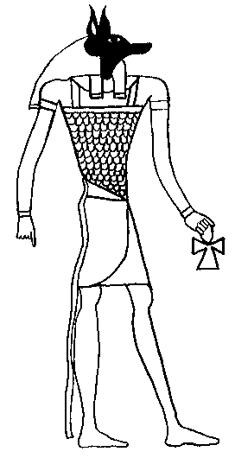

16. I'm the goddess of love birth and death. Who am I?
Hathor
Nut
Nefertiti
Hatshepsut
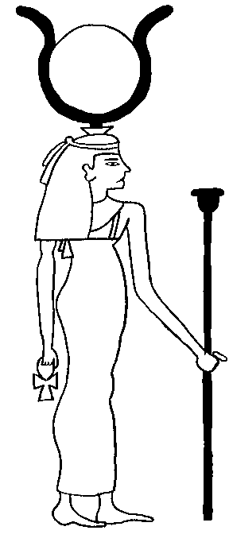

17. I'm the sun god. Who am I?
Amun -Re
Osiris
Horus
Ra
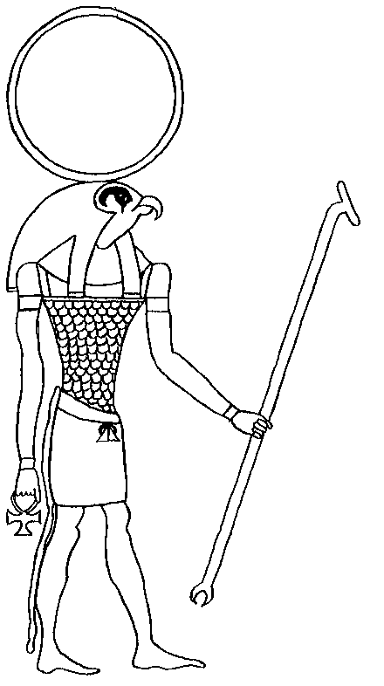

18. I'm the god of Thebes. Who am I?
Amon
Sobek
Nephthys
Carter

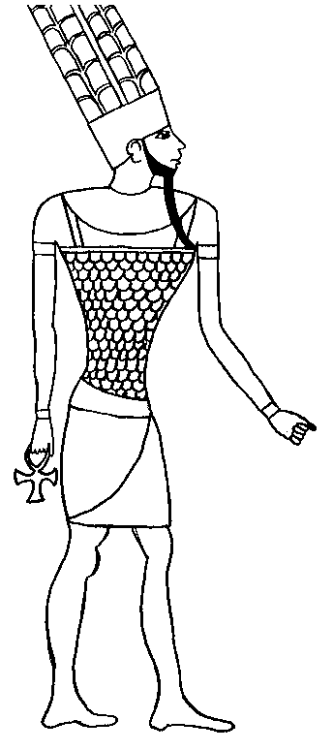

Egyptian Tomb Adventure
http://www.nms.ac.uk/education/kids/egyptian_tomb_adventure.aspx

19. The stela tells you?
20. The tomb is protected by?
21. Inside the coffin I found a…
What is something you learned on your Egyptian Tomb Adventure?

The Mummy Maker
http://www.bbc.co.uk/history/interactive/games/mummy_maker/index_embed.shtml

22. Who is Kha?
23. Who is Ramose?
24. What is the first tool used?
25. What body part does Ramose need to keep?
26. How do you write Ramose’s name in hieroglyphs?
27. Do you use oil then resin or resin then oil?
28. What is something you learned about the mummification process?

